Enhancing Performance Of Operating System Using Machine Learning

Project Members:
1. Lakshay Bansal (287/CO/12)
2. Ravish Mahur (339/CO/12)
3. Rishab Banerjee (340/CO/12)

CONTENTS
1. ABSTRACT………………………………………………………………………………………
2. WORK HITHERTO
2.1 COURSES PURSUED………………………………………………………
2.2 RESEARCH PAPERS READ……………………………………………..
3. VARIOUS MACHINE LEARNING ALGORITHMS

3.1 Linear Regression…………………………………………………………..

3.2 Logistic Regression…………………………………………….

3.3 Neural Networks…………………………………………………………....

3.4 K-Means …………………………………………………...
3.5 Support Vector Machines……………………………………………………..

4. FOCUS AREAS OF OS……………………………………………………
4.1 Process Scheduling
4.2 Memory Management
4.3 Disk Scheduling
4.4 Cache Replacement

5. SUMMARY……………………………………………………………………………………

WORK HITHERTO

Courses Done
- Machine Learning (Dr. Andrew Ng, Stanford University)
- Introduction To Data Science (Dr. Bill Howe, Washington University)
- Artificial Intelligence(UC Berkeley)
- R Programming (Dr. Roger Peng, John Hopkins )
- Introduction To Linux (edX)

Research Papers Studied:
- Self Learning Disk Scheduling (IEEE)
- Applying Machine Learning Techniques to improve Linux Process Scheduling (IEEE)
- To Collect Or Not to Collect? Machine Learning For Memory Management ()
- Dynamic Multicore Resource Management: A Machine Learning Approach

PROCESS SCHEDULING

Intuition
Generally process schedulers allocate CPU time slices to a process according to a scheduling algorithm that does not use any previous execution history of the process. It might be possible to better utilize resources if we could “recognize” a program and predict its resource requirements.

Approach followed (in the research paper read):
Predictive scheduling based on decision trees using static and dynamic attributes (size of program, data size, type of imput etc) reduced the TaT by about 6%. This was due to a reduction in the number of context switches needed to complete the process execution.
Modifications/ Improvements Possible:
Application of other techniques like neural networks and comparison of the overheads and performance and find the best possible alternative.

DISK SCHEDULING

- The performance of disk I/O schedulers is affected by many factors such as workloads, file systems, and disk systems. Disk scheduling performance can be improved by tuning scheduler parameters such as the length of read timers. Scheduler performance tuning is mostly done manually.
- To automate this process, we will study four self-learning disk scheduling schemes:
Change-sensing Round-Robin, Feedback Learning, Per-request Learning, and Two-layer Learning.
- Experiments show that the novel Two-layer Learning Scheme performs best. It integrates the workload-level and request-level learning algorithms. It employs feedback learning techniques to analyze workloads, change scheduling policy, and tune scheduling parameters automatically.
- We will discuss schemes to choose features for workload learning, divide and recognize workloads, generate training data, and integrate machine
learning algorithms into the Two-layer Learning Scheme.
- We will compare the accuracy, performance, and overhead of five machine learning algorithms: decision tree, logistic regression, naı¨ve Bayes, neural network, and support vector machine algorithms.
- Experiments with real-world and synthetic workloads show that self-learning disk scheduling can adapt to a wide variety of workloads, file systems, disk systems, and user preferences. It outperforms existing disk schedulers by as much as 15.8 percent while consuming less than 3 percent - 5 percent of CPU time.

Change-Sensing Round-Robin Selection

- The self-learning core in the operating system invokes all schedulers in a round-robin fashion
- Phases
–Phase 1: Selection phase
–Phase 2: Execution phase

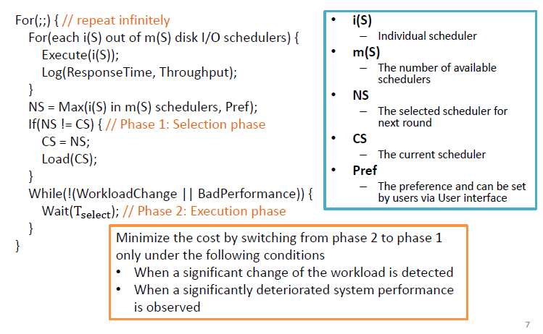

Feedback Learning

- The round-robin execution and switching are moved offline
- Phase
–Phase 1: Training phase
–Phase 2: Decision phase
–Phase 3: Feedback phase

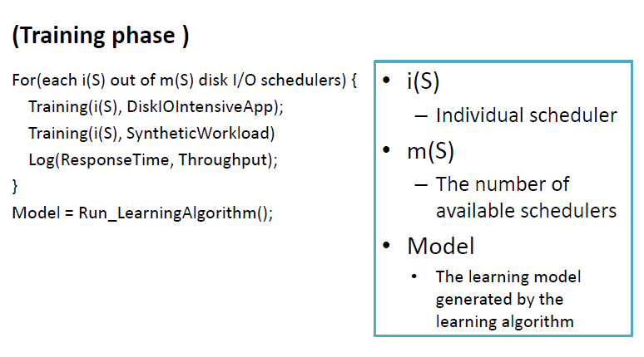
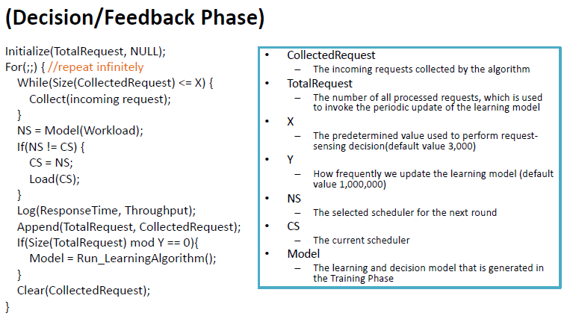

Per-Request Disk I/O Schedular

- The self-learning scheduler makes scheduling decisions at the request level instead of the workload level
- No longer log or compare the performance of the existing scheduling policies
- Phase
–Phase 1: Training phase
–Phase 2: Decision phase
–Phase 3: Feedback phase

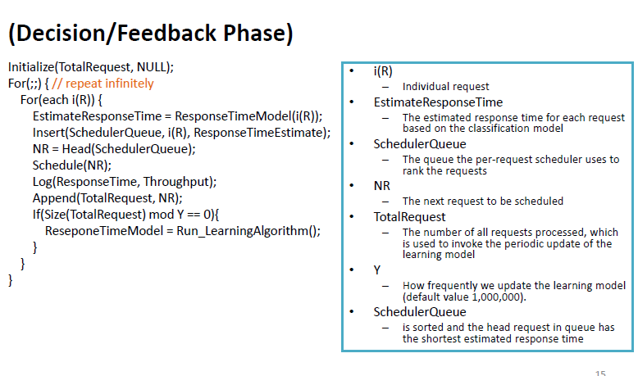

Tow-Layer Combined Learning Scheduler

- Phase 1: Training phase
–Step
1. Train the per-request decision scheduler by the methods in Algorithm 3
2. Train the scheduling scheme that consists of traditional schedulers plus per-request decision scheduler by the training procedures for Algorithm 2

- Phase 2: Decision phase / Phase 3: Feedback phase
• Remain mostly unchanged, except that the per-request decision scheduler becomes one of the possible schedulers

Potential Machine Learning Algorithms

- C4.5 decision tree algorithm
–C4.5 generates a decision tree, which is a classifier in the form of a tree structure, based on the ID3 algorithm

- Logistic regression
–Logistic regression is a regression method for Bernoulli-distributed dependent variables that utilizes a logistic function as the link function
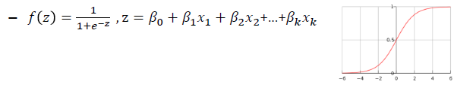

- Naïve Bayes
–The Naïve Bayes classifier applies Bayes' theorem with Naïve independence assumptions

- Neural networks
–The neural network (NN) is an adaptive system that adapts itself based on external or internal information that travels through the network

- SVM(Support Vector Machine)
–The SVM algorithm maps input vectors to a higher dimensional space

